PROJECT REPORT


Report Title: Store Sales Data Analysis
Session: 2023-2027
(Reg No. 2023-UOK-045041)
Submitted To: Sir Bilal Ahmed
Subject: Intro to DataScience
Submitted By: Arooj Yasin
Date of Submission: Dec 3 , 2025
DEPARTMENT OF DATA SCIENCE
FACULTY OF COMPUTING AND ENGINEERING
UNIVERSITY OF KOTLI AZAD JAMMUA AND KASHMIR

Introduction:
Store sales data analysis is the process of collecting, examining, and interpreting historical sales and related retail data to uncover insights that inform business decisions, such as optimizing inventory, improving marketing, and understanding customer behavior.
Objective:
The key objectives of this project are:
To analyze overall sales performance.
To identify top-selling and low-selling products.
To study monthly and yearly sales trends.
To compare sales across different regions.
To understand the impact of discount, quantity, and category on sales.
To provide recommendations to improve business growth.
Dataset Description:
The dataset used for this project contains historical sales records.
Key features/columns include:
Order ID – Unique order number
Order Date – Date of purchase
Product Name
Category / Sub-category
Quantity Sold
Sales Amount
Profit
Discount
Region / City
The dataset contains structured numerical and categorical data.
Project:
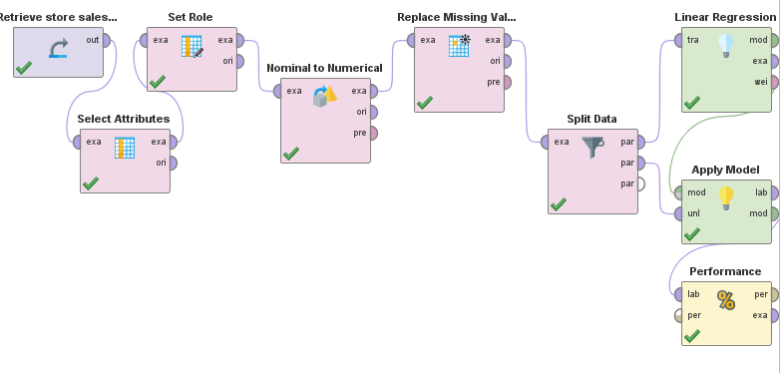
Data Cleaning and Preprocessing:
Removed duplicate entries.
Handled missing values.
Converted Order Date into proper date format.
Standardized product and category names.
Filtered irrelevant or empty records.
Added new calculated columns such as Year, Month, Profit Margin, etc.

Data Visualization:
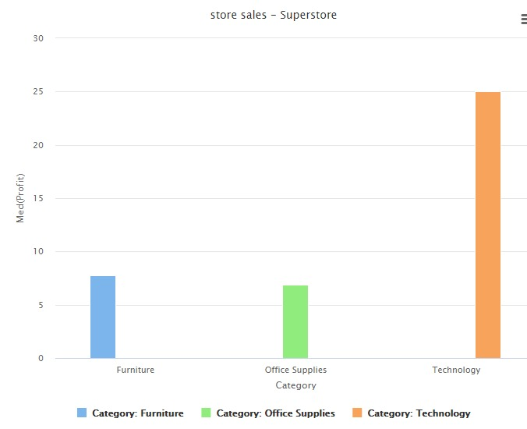

Result:
Blue Line show the furniture Category
Green shows the Office Supplies Category
Orange shows the Technology Category
We see that orange line is very high means technology is high profit. And green shows very low means low profit..

Sales by Categories

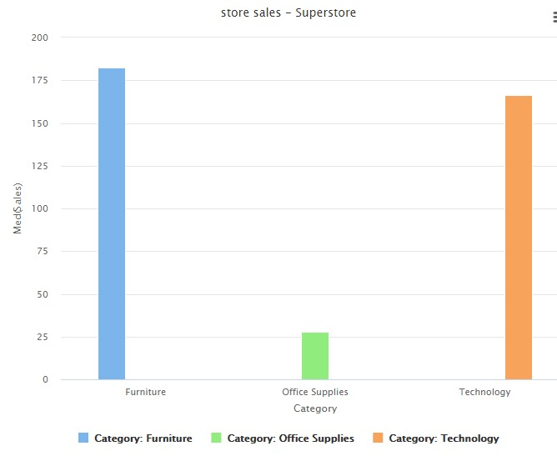
Result:
Blue Line show the furniture Category
Green shows the Office Supplies Category
Orange shows the Technology Category
We see that blue line is very high means furniture sale is high. And green shows very low means low Saleing.
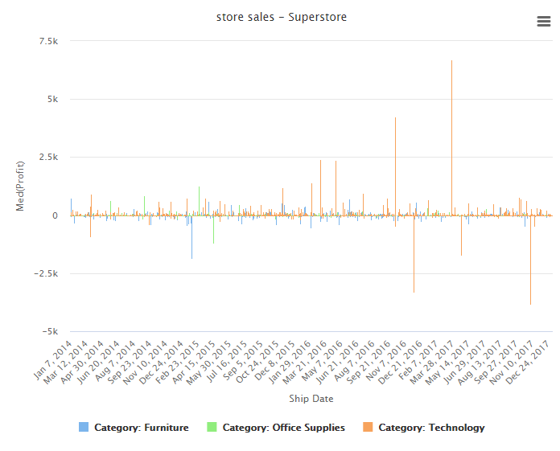

Tools:
I use the Rapid Miner for this Project.
Load the CSV file in Rapid Miner.
We also use the python for this.
Conclusion:
This Store Sales Data Analysis project shows that proper data analysis helps businesses understand performance, predict sales trends, and make better decisions. Through EDA, key sales drivers were identified, and insights were gained about customer behavior, seasonal trends, and product performance.
Data science techniques helped convert raw data into meaningful information that supports business planning.
Reference:
1. Rapid Miner – RapidMiner was used to preprocess the store sales dataset, handle missing values, convert nominal attributes into numerical form, and build a Linear Regression model for sales prediction.
2.Online resources – Youtube , Google and AI tools
3.Classroom lectures Notes
GitHub Upload:
